Recertification Application

- Log into EDvera with your email address and password. You will see three tabs: Dashboard, Documents, and Approvals. Select the Documents tab to begin.

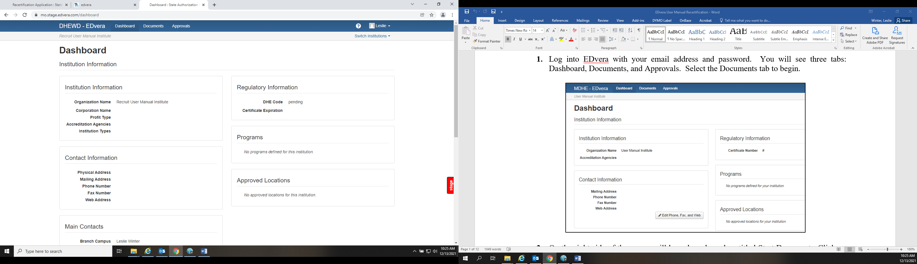

- On the right side of the screen will be a drop down box titled Start Document. Click on that box then select “Recruit Recertification Application” from the dropdown menu.

- Review the attestations then click the check box. Click Continue.

The Recertification Application is divided into four sections:
- Institutional Standards
- Personnel Standards
- Program Standards
- Student Services Standards

Institutional Standards

- Item 1 - Review the Institution Information and Mailing Address. If the information is correct, click Yes and move to Item 2. If any information is not correct, select No.
  - If changes are non-substantive (e.g., telephone, mailing address), contact the DHEWD and request the school’s Profile be corrected.
  - If changes are substantive (instructional location change), you will be required to complete a Location Change Application.

- Item 2 – If the school has been newly accredited or changed accreditation (institutional or programmatic) and EDvera has not been updated, select Yes and complete the appropriate document (New Accreditation Application or Accreditation Change Application).

If the school has not changed accreditation, click “No”; unaccredited schools select “The school is not accredited.”

- Item 3 – If the school has renewed accreditation, click Yes and upload the most recent verification document from the accrediting agency.

If the school has not renewed accreditation, click “No”; unaccredited schools select “The school is not accredited.”

- Accredited schools under disciplinary actions by its accreditor not previously disclosed to the DHEWD must click Yes and upload a copy of the accrediting agency’s actions.

If no disciplinary actions have been taken, click “No”; unaccredited schools select “The school is not accredited.”

- Click “Save and Proceed to Next Section.”

Personnel Standards

- Review and click the check boxes for the two attestations regarding institutional personnel.

- Enter the number of full time and part time administrators and instructors for the campus.

As a reminder, if someone is both an administrator and an instructor, they must be counted as part time in each (even if the employment is full time).

You must enter a number in each box, even if the number is “0” or you will receive an error when submitting the document.

- Scroll down and click “Save” to retain the data you have entered.

- Review the Key Administrative Personnel listed for your school. Institutions are required to have one person identified for each of the following administrative functions:
  - Campus Director
  - Chief Academic Officer
  - Data Coordinator
  - Financial Officer
  - State Licensing Liaison
  - Student Financial Assistance Officer

- If one or more key administrators are missing, and those individuals are currently entered in the EDvera system, enter their name(s) in the text box and indicate the key function they are to fill. DHEWD staff will make the update in the system.

- If key administrators are missing and are not in the system, the school must complete a New Administrative Personnel document for each and identify the key function held.

- If an individual is listed as a key administrator but no longer holds that role and/or has left the institution, enter that person’s name in the text box and indicate the reason for change. DHEWD staff will make the update in the system.

- Scroll down and click “Save” to retain the data you have entered.

- Review the Instructional Faculty listed for your school. If the information is correct, click “Save and Proceed to Next Section.”

Accredited institutions are not required to submit individual instructor information during recertification.

- If instructors are missing, the school must complete a New Instructor document for each.

NOTE: The total number of instructors must match the number of instructors the school entered in the full time / part time table on this form. For example, if a school listed one full time instructor and two part time instructors, the school must have three instructors on the list in this section.

- If an individual is listed as an instructor but has changed roles or is no longer with the institution, enter that person’s name in the text box and indicate the reason for change. DHEWD staff will make the update in the system.

- Click “Save and Proceed to Next Section.”

Program Standards

- Review and click the check box attestations regarding program standards.

- Review the list of programs and indicate all information is correct by clicking Yes. If any information is incorrect or if a program is missing, click No and complete a Program Change Application for each incorrect program or a New Program Application for each missing program.

- Click “Save and Proceed to Next Section.”

Student Services Standards

- Review and click the check box regarding school publications.

- Upload the current version of the school’s publications (catalog, handbook, brochures, etc.) that include required information disclosures. Review the Catalog Checklist Items to ensure all required disclosures are included on the uploaded documents. If applicable, include page numbers where the required disclosures may be found in the catalog.

- Review and click the check box regarding the enrollment agreement.

- Upload a copy of a completed enrollment agreement for a student who enrolled in the last calendar year.

- Review and click the check box regarding the student transcript.

- Upload a copy of a completed transcript for a student who graduated in the last calendar year.

- Scroll to the bottom of the form and click “Save” to retain all entered information.

- Click on the “+Recruit Annual Statement of Income and Expenses” button to complete the document. As a reminder, this is a financial document so must be completed by the school’s Chief Administrator in EDvera. Once form is completed Click “Save” then click “Submit.”

***DO NOT SEND RECERTIFICATION PAYMENT UNTIL INSTRUCTED BY THE DEPARTMENT.

- Click on the “+ Recruit Annual Statement of Enrollments, Completions, and Employment” button to complete the document. Once form is completed Click “Save” then click “Submit.”

Use the last option available (the mst current date)

